**LAB 6- Index and Match Function Lab**

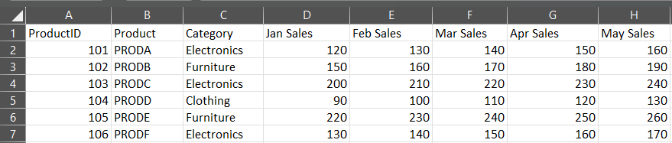

1. Use INDEX and MATCH to find the sales for Product C in March.

2. Use INDEX and MATCH to find the category for Product E.

3. Use INDEX and MATCH to find the maximum sales for Product B

across all months.

4. Use INDEX and MATCH to find the month with the maximum sales for Product A.

5. Use INDEX, MATCH, and SUMIF to sum the sales for all products in the "Electronics" category for April.

6. Use INDEX and MATCH to calculate the average sales for Product D across all months.

7. Use INDEX and MATCH to find the sales for Product ID 105 in May.

8. Use INDEX and MATCH to create a dynamic lookup where the user can input a product and a month, and the formula returns the corresponding sales.

**Solutions:**

